**The Effects of Repeating Pitches on Pitcher Success Rate**

**Written By: Michael Drake**

It’s the bottom of the 6th inning in Minute Maid Park. Down 3-2 and facing elimination, the Yankees are trailing the Astros 4-2 in game six of the 2019 American League Championship Series. Facing Yordan Alvarez with two out and nobody on, Tommy Kahnle needs to keep the game within reach to give his offense a shot at coming back. After falling behind 2-0 to Alvarez, Kahnle comes back and gets a strike looking on a changeup up in the zone. On 2-1, Kahnle throws a changeup below the zone and gets Alvarez to swing through it for strike two. After getting a swinging strike and the count now at 2-2, what does Kahnle do to try to get Alvarez out? Does he attempt to repeat the previous pitch after successfully inducing a swinging strike, or does he throw a different pitch in anticipation that Alvarez is expecting the same pitch? Kahnle repeats the changeup below the zone and gets Alvarez swinging on strikes to keep the Yankees within two runs.

Pitch sequences like these are very intriguing because of the variety of factors that affect the at-bat, such as the pitcher and hitter’s game plans, game situations, and recent performance. It is a big reason organizations carefully study pitch sequencing. I wanted to quantify and analyze the effectiveness of situations like Kahnle’s against Alvarez. That is, I wanted to determine the most effective two-strike strategy for the pitcher after the batter swung and missed on the previous pitch. Organizations can then share these findings with their pitchers, so they have better success as a staff.

Data Acquisition

Data for the regular season from 2017-2019 came from Baseball Savant. For the analysis done in this project, swinging strikes with one strike in the count and the pitches immediately following were the only pitches analyzed. The result of at-bats is not considered in this analysis unless it was the pitch following a swinging strike with one strike. This is because the study only looked at how successful the second pitch was.

When looking at the data provided by Baseball Savant, each pitch had a pitch type designation and where in the zone the ball crossed the plate, amongst other data. For my analysis, a pitch is considered repeated if both the pitch type and zone where the ball crossed the plate are repeated in consecutive pitches.

For the remainder of this article, the swinging strike with one strike will be referred to as the first pitch, and the next pitch will be referred to as the second pitch. For second pitches that are the same pitch type and location, they will be referred to as the same or repeated pitch. Otherwise, the second pitch will be referred to as different.

Analyzing Out and Strikeout Percentage

Quantifying a pitcher’s success over a season can become complicated when looking at stats like Earned Run Average (ERA), Walks + Hits Per Inning Pitched (WHIP), and win-loss record. However, pitchers are ultimately trying to accomplish one thing when on the mound, and that’s getting outs. These outs include flyouts, groundouts, popouts, lineouts, and strikeouts. Strikeouts are the most efficient out for pitchers because it takes any chaos involved with balls hit in play out of consideration. These facts were the basis of my first analysis, where I looked at the percentage of pitches that lead to either an out or strikeout for both situations in which a pitcher threw a repeated pitch or a different pitch. Below are two bar graphs that compare these percentages for both cases from 2017-2019.

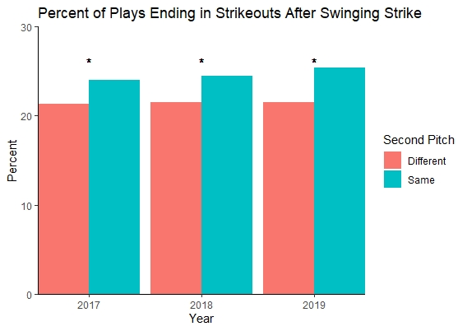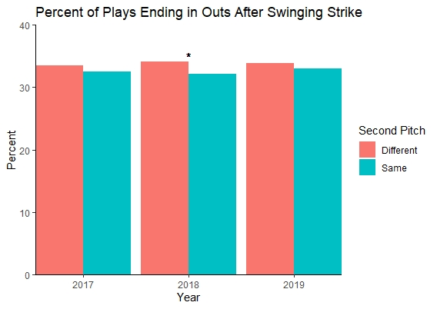

Note: The * above a given year shows that the difference between the two datasets for a given year is significant at a 95% confidence level.

The graph on the left shows that the percentage of repeated pitches that resulted in an out was less when compared to different pitches in every season from 2017-2019. However, only the difference in 2018 was considered significant. Whereas the graph on the right shows that the strikeout rate was higher in all three seasons for when the second pitch was the same when compared to being different. These results were significant in all three seasons.

I was somewhat puzzled with the fact that the two graphs indicate it is better to repeat pitches in terms of strikeout rate, but it is better to use different pitches in terms of out percentage. My first instinct would suggest that using the same pitch would be more successful than not because the difference in out percentage was small in comparison to the difference in strikeout percentage. However, I wanted to analyze the data further to determine whether I could confidently come to this conclusion. Instead of looking just at the percent of plays where an out or strikeout occurred, I wanted to consider the quality of contact.

Analyzing xwOBA

Baseball is a game of both skill and luck. For example, a hitter could go 0-4 with three lineouts in one game, while another hitter could go 3-4 with an infield single and two bloop singles in the same game. Although on paper it looks like the second hitter performed better, many experts would look at the quality of contact the first hitter made and say that he was unlucky. Statistics such as Expected Weighted On-Base Percentage (xwOBA) takes the quality of contact into account and will be used to analyze the data further.

Weighted On-Base Percentage (wOBA) provides an overall offensive value of a hitter based on a weighted average of batted ball events, such as singles, doubles, and home runs (2). xwOBA calculates the wOBA of a given batted ball based on exit velocity, launch angle, and, in some cases, the sprint speed of the batter (1). In simpler terms, xwOBA uses the quality of contact of a batted ball, along with data from previous seasons, to determine how successful a hitter should be. As a result, xwOBA is better for comparing the two datasets than out percentage because it effectively removes any luck involved.

The graph below shows the xwOBA for all second pitches from 2017-2019.

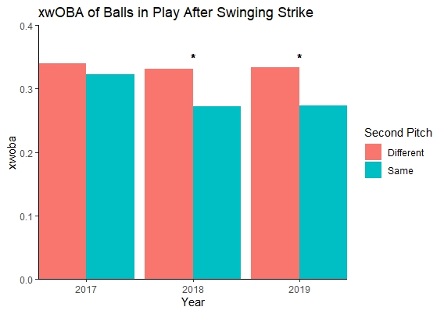

Note: The * above a given year shows that the difference between the two datasets for a given year is significant at a 95% confidence level.

Looking at these results, the xwOBA for repeated pitches is lower than that of different pitches in all three seasons from 2017-2019. The difference was considered significant for the 2018 and 2019 seasons.

Although it may seem clear that repeating pitches is more effective than not, I wanted to explore the large decrease in xwOBA for repeated pitches between the 2017 regular season and the 2018-2019 regular seasons. Since xwOBA is primarily affected by the exit velocity and launch angle of the batted ball, I looked at the distribution of types of balls in play. Baseball Savant defines six different “zones” that a batted ball can fall under based on these two attributes. The image below shows these six zones (3). xwOBA is the highest for batted balls that are considered barrels and are the lowest for those that are considered weak, topped, or hit under.

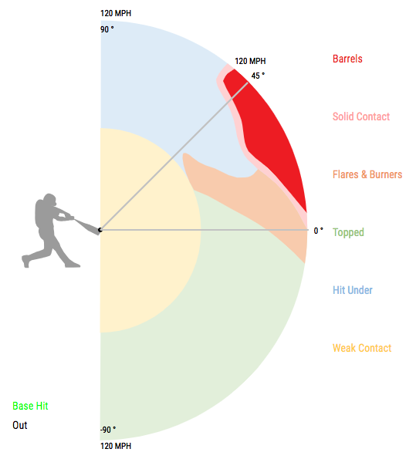

For there to be a significant decrease in xwOBA on repeated pitches, there would need to be a change amongst the distribution of these zones. The graphs below show the distribution of these batted ball zones over each season from 2017-2019.

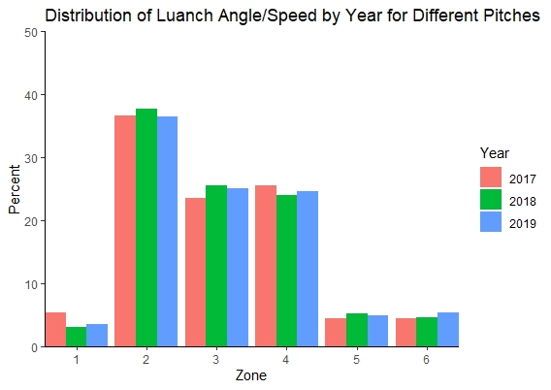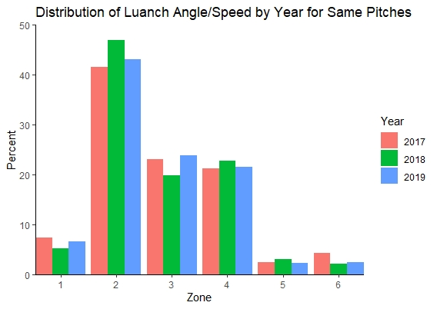

Note: The zones are defined as follows: 1 = Weak, 2 = Topped, 3 = Under, 4 = Flare/Burner, 5 = Solid Contact, 6 = Barrel.

It appears at first glance that the biggest changes from 2017 to 2018 for repeated pitches were in the percent of batted balls that were topped and hit under. However, the biggest change occurred on balls that were barreled up, where there was a 49.4% decrease in the percent of repeated pitches that were considered barreled balls. Similarly, the barrel percentage between 2017 and 2019 decreased by about 41.5%. This reduction in barreled balls is the primary reason why xwOBA for repeated pitches decreased by nearly 50 points between 2017 and the 2018-2019 seasons.

On the other hand, the barrel percentage for different pitches increased by 5.3% between 2017 and 2018, and by 22.0% between 2018 and 2019. This increase in barrel rate, along with the small changes amongst other hit types, explains why there was little change in xwOBA for different pitches between each of the 2017-2019 seasons.

I believe the most prominent reason for this reduction in barreled balls on repeated pitches between 2017 and 2018-2019 has to do with the pitches being thrown in these scenarios. This is analyzed in more detail below, but pitchers have begun using off-speed pitches more often, including on repeated pitches, because they are more challenging to hit.

Analyzing Individual Pitcher and Hitter Performance

The analysis conducted up to this point seems to show that repeating pitches is better than not. However, these results could be skewed by either high-performing pitchers or low performing hitters. The following analysis was conducted to determine whether my findings above are dependent on either of these factors.

Pitchers often have one or two pitches that they frequently use to get hitters out. Those that have the most effective pitches typically have a high spin rate (outside of split-fingers and knuckleballs). Spin rate not only increases the movement of the pitch, but it also makes it more difficult for the hitter to pick up the spin of the baseball and determine what type of pitch is thrown. Thus, in theory, a pitcher with high spin rate pitches are more likely to repeat pitches because of the higher probability of success.

Below is a table that lists the top ten pitcher/pitch combinations for repeated pitches in each season from 2017-2019.

|  |  |  |  |  |  |
| --- | --- | --- | --- | --- | --- |
| **2017** | | **2018** | | **2019** | |
| Pitcher – Pitch | Number of Times | Pitcher – Pitch | Number of Times | Pitcher – Pitch | Number of Times |
| Patrick Corbin – Slider | 28 | Patrick Corbin – Slider | 48 | Patrick Corbin – Slider | 49 |
| Ervin Santana – Slider | 22 | Jakob Junis – Slider | 24 | Robbie Ray – Slider | 26 |
| Corey Kluber – Curveball | 20 | Luis Severino – Slider | 22 | Shane Bieber – Slider | 25 |
| Zack Greinke – Slider | 20 | Kyle Gibson – Slider | 20 | Kenta Maeda – Slider | 24 |
| JC Ramirez – Slider | 19 | Carlos Carrasco – Slider | 18 | Kyle Gibson – Slider | 24 |
| Luis Avilan – Changeup | 19 | Zack Godley – Knuckle Curve | 18 | Marcus Stroman – Slider | 24 |
| Jacob Barnes – Cutter | 18 | Brad Peacock – Slider | 17 | Charlie Morton – Curveball | 22 |
| Ryan Tepera – Cutter | 18 | Dylan Bundy – Slider | 17 | Will Smith – Slider | 22 |
| Marcus Stroman – Slider | 17 | Jared Hughes – Sinker | 17 | Jon Gray – Slider | 21 |
| Luis Severino – Slider | 16 | Kevin Gausman – Split Finger | 17 | Sonny Gray – Slider | 21 |

One thing I noticed from this table—outside of the fact that Patrick Corbin’s slider was the top repeated pitch all three seasons—was that most of the top repeated pitches each year were off-speed pitches. In fact, 22 of these 30 were sliders. The table above shows how off-speed pitches, especially sliders, have become the go-to pitch for getting hitters out.

As previously mentioned, pitch effectiveness often improves as spin rate increases, which makes it more likely that pitches with a high spin rate are more useful for repeated pitches. To determine if spin rate has any correlation with the success of the second pitch, I needed to normalize the spin rate data of all pitches. To do this, I calculated the percentile of a pitcher’s average spin rate for that particular type of pitch in a given season. For example, Patrick Corbin’s slider in 2017 fell in the 73.7th percentile in the spin rate for all sliders thrown in 2017. Below are scatterplots generated for each season comparing the spin rate percentiles to the xwOBA of repeated pitches, along with the calculated trend line to see if there was a correlation. The data below was filtered to those with pitchers who repeated the second pitch at least five times to eliminate data points with only a few extreme values of xwOBA.

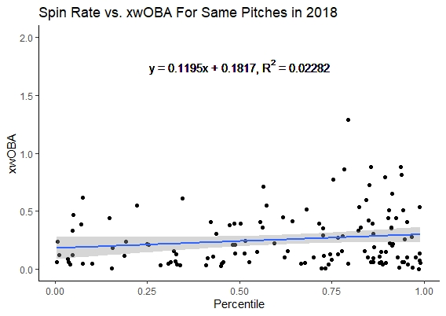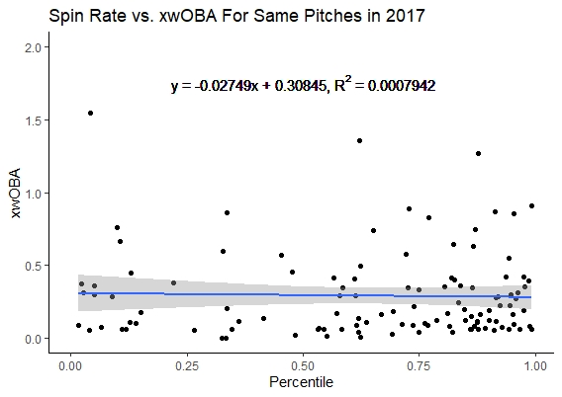

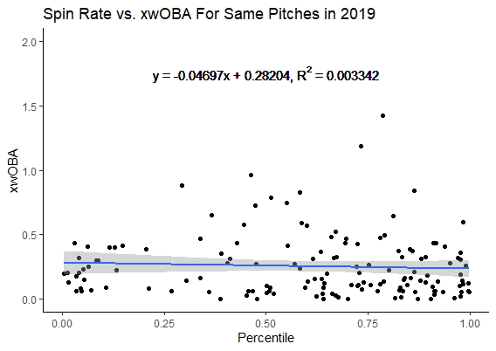

As evident in all three plots above, there is no correlation between a pitch’s spin rate percentile and the xwOBA of balls in play for repeated pitches. This means that no matter how good a pitcher’s pitch may be, the expected results cannot be predicted.

Similar to high-performing pitchers, low-performing hitters could skew the data. In theory, if a hitter is struggling throughout a season, they are also less likely to succeed against all pitches, including repeated pitches.

Below are scatterplots generated for each season comparing a hitter’s season-long xwOBA to their xwOBA against repeated pitches, along with the calculated trend line to see if there was a correlation. The data below was filtered to those with hitters who faced at least five repeated pitches to eliminate data points with only a few extreme values of xwOBA.

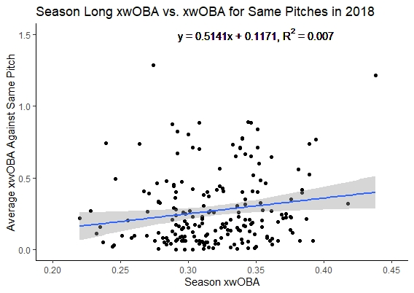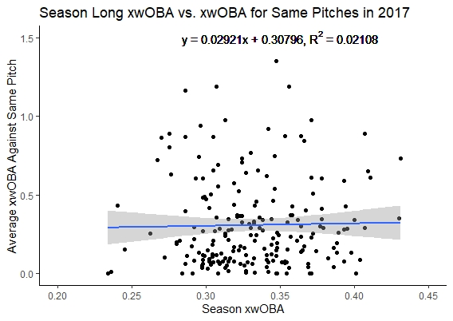

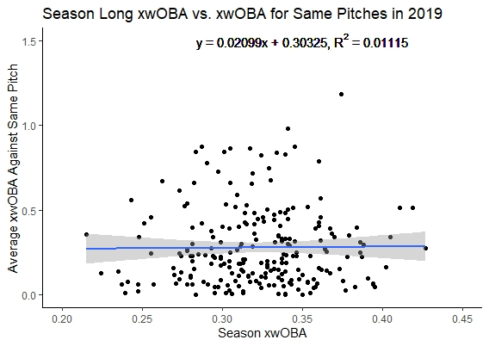

Similar to the previous scatterplots of spin rate versus xwOBA, there is no correlation between the batter’s talent (represented as their season xwOBA) and their performance against repeated pitches. This means that no matter how talented the hitter is, the expected results cannot be predicted.

Conclusion

It’s safe to say that my previously discussed findings are valid in that it’s more effective to repeat a pitch than not. It shows that repeated pitches are more likely to not only record a strikeout but induce weaker contact. Based on the scatterplots looking at the effects of pitcher spin rate, it is evident that the pitcher’s talent does not affect their performance on repeated pitches. Similarly, from the hitter’s perspective, their success rate on repeated pitches is not correlated with their overall season performance. Pitchers can use this information to develop better game plans heading into a game that would generate more success over the course of the regular season.

Future Research

My analysis should be expanded in the future to examine other implications of repeating a pitch. It would be interesting to determine if repeating pitches with one strike would yield different outcomes. Another avenue that future analysts could evaluate is the results of at-bats when a pitcher repeats the same pitch three times in a row. This analysis could also include a comparison of specific pitch effectiveness when repeated, such as repeated changeups vs. repeated curveballs.

References

(1) “Expected Weighted On-Base Average (XwOBA).” Major League Baseball, m.mlb.com/glossary/statcast/expected-woba.

(2) Slowinski, Steve. “WOBA.” *WOBA | Sabermetrics Library*, Fangraphs, 15 Feb. 2010, library.fangraphs.com/offense/woba/.

(3) “Statcast Search CSV Documentation.” *Baseballsavant.com*, baseballsavant.mlb.com/csv-docs.